**Introduction**

The team Block Breaker designs and builds a 3D printing material tester which can test the tensile strength and the impact resistance strength of different types of 3D printing materials and uploading the testing results automatically to the database that shared to the community. This operation manual aims to help the community to assemble the tester correctly to not only fulfill the designated function but also to protect the user from the potential risk during the operation or assembly process.

**Part A: Check the bill of materials**

Before moving on to Part B Make sure the required materials listed on the bill of materials (BOM) are ready. You can check the bill of materials in the last section.

**Part B: Assembly**

**Step B.1: Check the 3D printing parts**

1. Before starting the assembly process, make sure the required 3D printing parts for the tester are available for the assembly process. Figure B.1.1 shows the 3D printing parts. Since the precision performance may vary between different brands of printers, you may need to adjust some dimensions of the 3D printing parts.

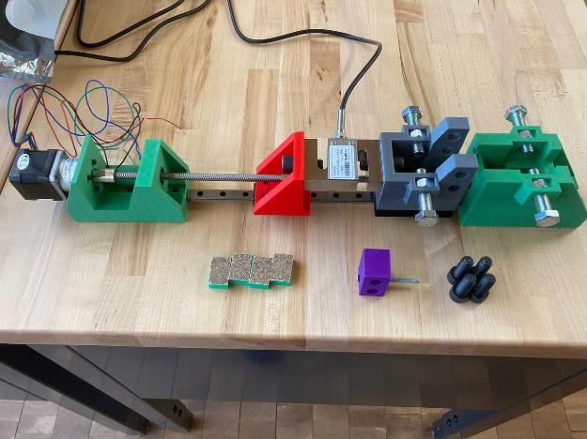

**1**

**2222**

**33 3**

**4**

**5**

**6**

Figure B.1.1: Required 3D printing parts

1– Motor Block, 2– Leading Block, 3 – Moving Grip, 4 – stationary Grip, 5 – Hammer Block, 6 – Clamp Block

**Step B.2: Installing the Leading Block**

1. Use four M3x0.5mm 8mm lg screws to connect the Leading Block to the rail carriage as Figure B.2.1 shown.

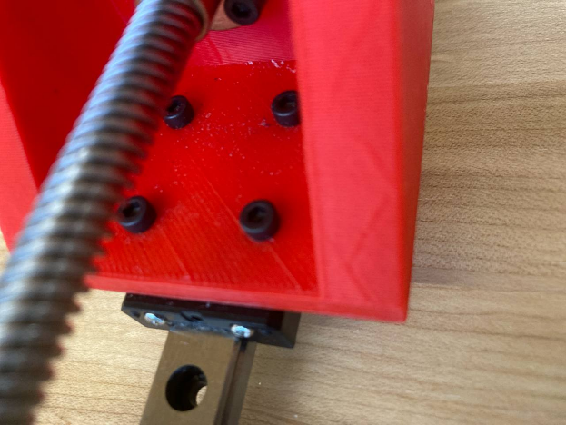

Figure B.2.1: The installation of four M3x0.5mm 8mm lg screws

1. Unscrew the brass nut of the lead screw and install the nut onto the Leading Block with four M3x0.5mm 20mm lg screws. Tighten each screw with M3x0.5mm hex nuts. Figure B.2.2 and B.2.3 show the configurations.

|  |  |
| --- | --- |
|  |  |
| Figure B.2.2: The installation of brass nuts with four M3x0.5mm 20 lg screws | Figure B.2.3: The installation of M3x0.5mm hex nuts |

1. Insert the M12x1.75mm 30mm lg screw into the Leading Block as Figure B.2.4 shown.

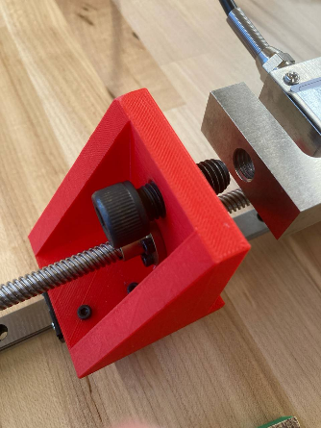

Figure B.2.4: Install the M12x1.75mm 30mm lg screws

**Step B.3: Installing the Moving Grip**

1. Like the process of installing the Leading Block, use four M3x0.5mm 8mm lg screws to fix the block onto the rail carriage. Be careful with the direction of the Moving Grip. Figure B.3.1 shows the configuration.

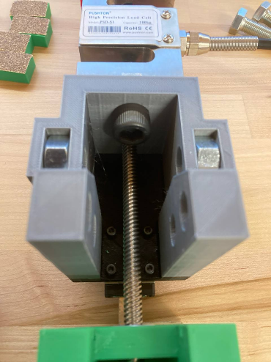

Figure B.3.1: The configuration of Moving Grip

***\*\*Note**: The rail may only carry only one rail carriage when delivered. Check the link below to gather the information about how to install another carriage and lubricate it correctly:***

[***https://gulfcoast-robotics.com/pages/mgn12-linear-rail-lubrication-procedure***](https://gulfcoast-robotics.com/pages/mgn12-linear-rail-lubrication-procedure) ***(Refer to step 3 and 4a only. The lubrication set is provided in the BOM)***

1. Again, insert the M12x1.75mm 30mm lg screw into the Moving Grip as Figure B.3.1 shown.
2. Insert the M12x1.5mm hex nuts into both outer slots as Figure B.3.2 shown.

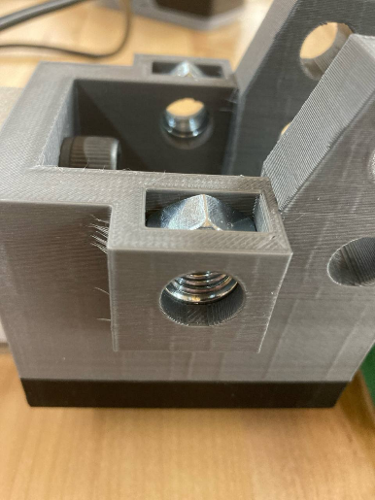

Figure B.3.2: The installation of M12x1.5mm hex nuts

**Step B.4: Installing the Motor Block**

1. Align the base hole extrusions of the Motor Block with the rail holes (this will require you to remove the anti-fall strips on the very end of the rail) and make sure the end of the block reaches the end of the rail. Use three M3x0.5mm 20mm lg screws to connect the block to the rail; fasten the screw from the bottom. Tighten the screws with three M3x0.5mm hex nuts. Figure B.4.1 and B.4.2 show the configurations.

|  |  |
| --- | --- |
|  |  |
| Figure B.4.1: Install the M3x0.5mm 20mm lg screws | Figure B.4.2: Install the M3x0.5mm hex nuts |

1. Insert two deep groove ball bearings into the Motor Block as Figure B.4.3 and Figure B.4.4 shown.

|  |  |
| --- | --- |
|  |  |
| Figure B.4.3: Insert the bearing | Figure B.4.4: Insert the bearing |

1. To install the stepper motor, insert the motor shaft through the inner extrusion holes and align the motor so that four M3x0.5mm 8mm lg screws can be fastened through the outer extrusion holes as Figure B.4.5 shown.

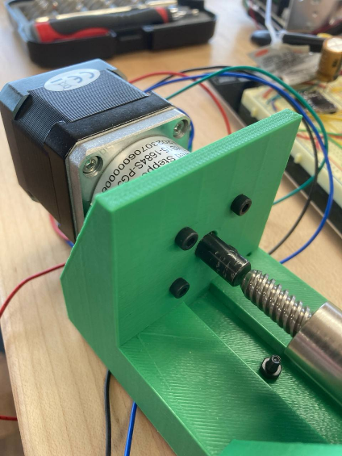

Figure B.4.5: Install the stepper motor

1. Stick the contact surface of the base with sanding sheet by using hot glue as Figure B.4.1 shown.

**Step B.5: Installing the Stationary Grip**

1. Similar to the process of assmbling the Motor Block, make sure the Staionary Grip is aligned with the rail so that three M3x0.5mm 20mm lg screws can be fasten through the extrusion holes. Again, fasten the screws from the bottom and tighten them with M3x0.5mm hex nuts as Figure B.5.1 and B.5.2 shown.

|  |  |
| --- | --- |
|  |  |
| Figure B.5.1: Fasten the M3x0.5mm 20mm lg screws from the bottom | Figure B.5.2: Tighten the screws with M3x0.5mm hex nuts |

1. Insert the M12x1.5mm hex nuts into both outer slots as Figure B.5.3 shown.

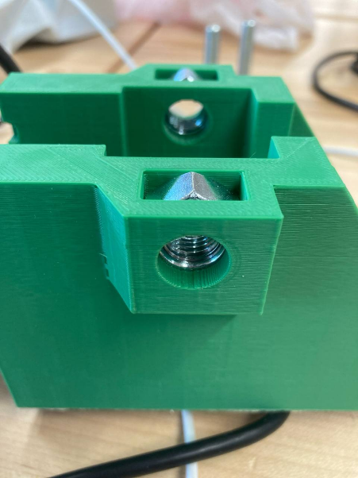

Figure B.5.3: Insert M12x1.5mm hex nuts into the slots

1. Insert the deep groove ball bearing into the Staionary Grip as Figure B.5.4 shown

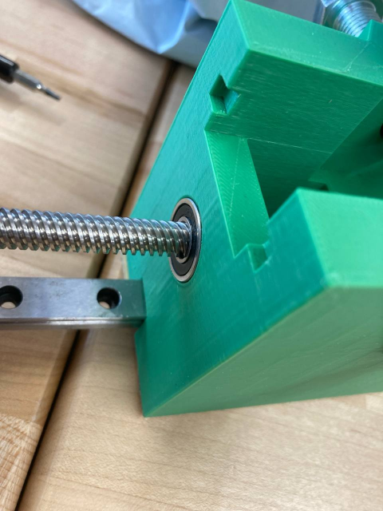

Figure B.5.4: Insert the bearing

1. Again, Stick the contact surface of the base with sanding sheet by using hot glue as Figure B.5.1 shown.

**Step B.6: Installing lead screw and connect it to the motor**

1. Turn the lead screw into the extrusion hole at the end of the Stationary Grip until it touches the motor shaft. Figure B.6.1 shows the position of the extursion holes.

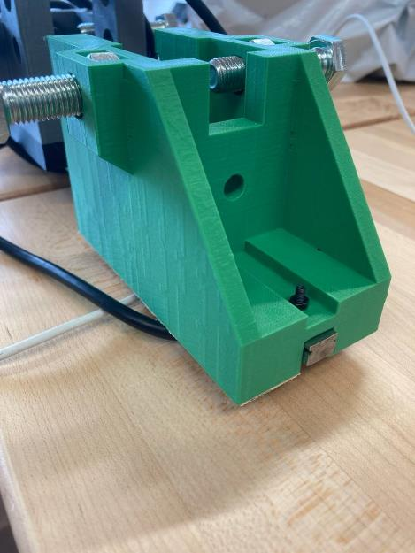

***Turn in the lead screw from here***

Figure B.6.1: The extrusion hole at the Stationary Grip

1. Install the coupler to connect the lead screw and the motor shaft; connect the motor shaft with the smaller hole of the coupler. Use the specified screws provided from the coupler set to tighten the connection as Figure B.6.2 shown.

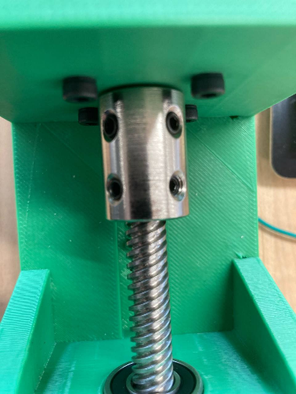

Figure B.6.2: Install the coupler

**Step B.7: Assemble the Clamp Block, the Hammer Block, and the S-sensor (load cell)**

1. Stick the sanding sheet to the base of the Clamp Block with hot glue as Figure B.7.1 shown.

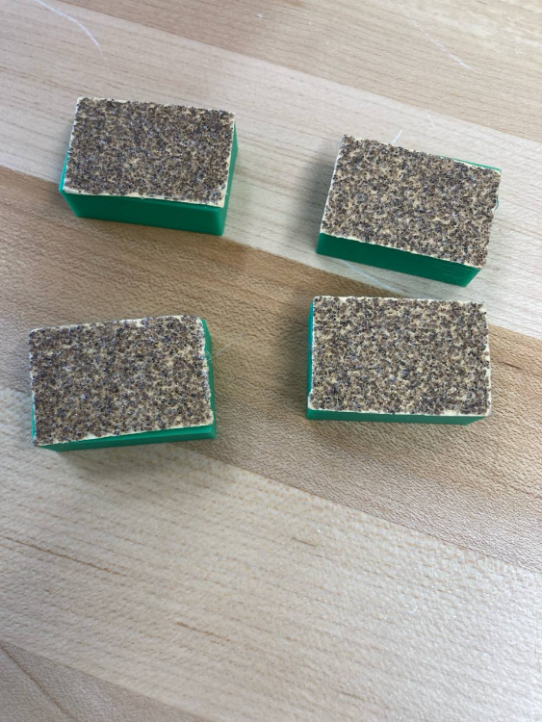

Figure B.7.1: The configuration of the Clamp Block

1. Insert the No.10 2-½'’ drilling screw into the Hammer Block as Figure B.7.2 shown

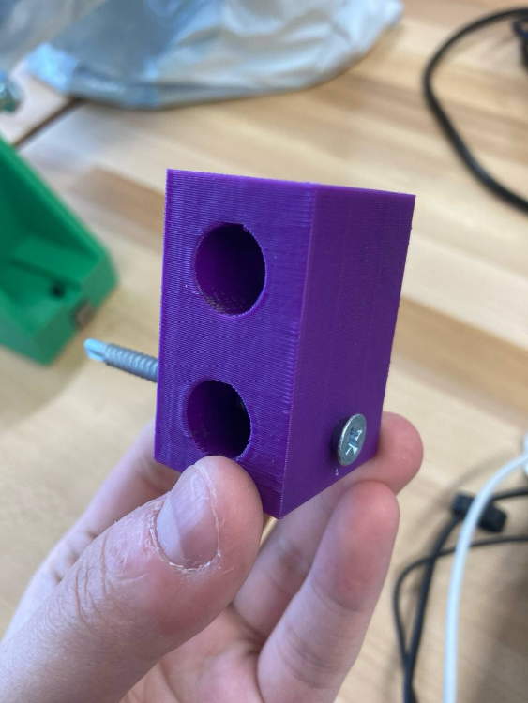

Figure B.7.2: Insert the drilling screw

1. Use the M12x1.75mm 30mm lg screws installed previously to fix the S-sensor (load cell) betwen the Leading Block and the Moving Grip as Figure B.7.3 shown.

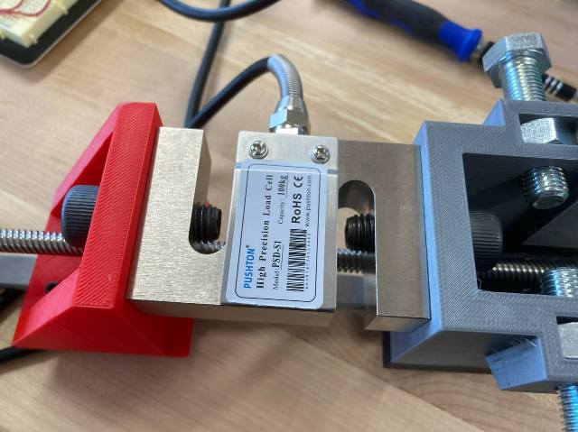

Figure B.7.3: Intsall the S-sensor (load cell)

**Part C: Test configurations**

By this time, the tester should be assmbled and functional. This section introduces how to build the configuration for both tensile test and impact resistance test.

**C.1: Tensile test**

1. Fasten M12x1.5mm 50mm lg screws for both Stationary Grip and Moving Grip through the M12x1.5mm hex nuts assembled previously as Figure C.1.1 shown.

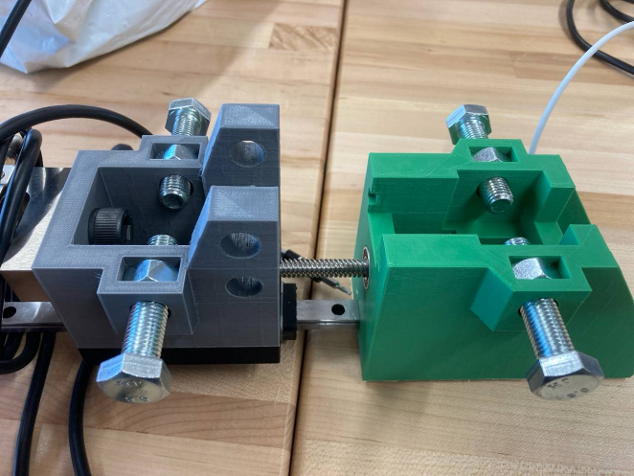

Figure C.1.1: Fasten the M12x1.5mm 50mm lg screws

1. Connect the Clamp Block to the M12x1.5mm 50mm lg screws as Figure C.1.2 shown.

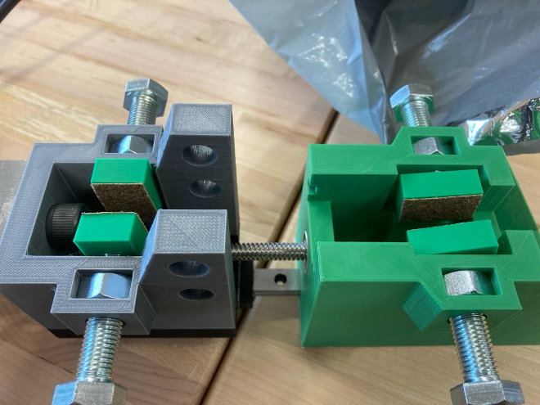

Figure C.1.2: Place the Clamp Block

1. Adjust the distance between the grips. You can do that by manually turning the coupler.
2. Place the testing specimen in the center and tighten it as much as possible by turning the screws. Make sure you can see the sanding sheet on the Clamp Block has relatively fully contact with the specimen. Figure C.1.3 shows the configuration.

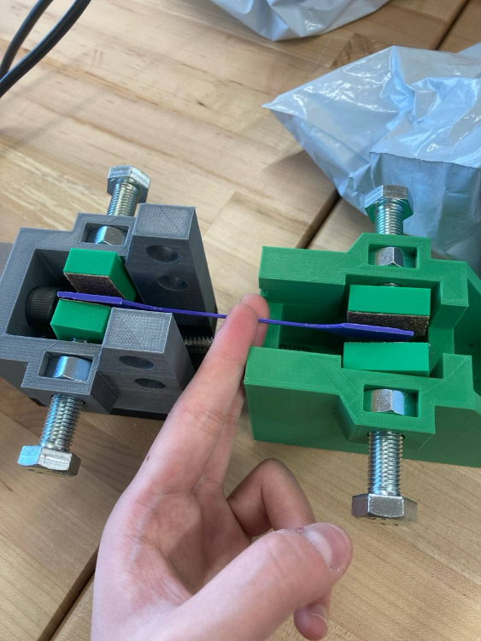

Figure C.1.3: The configuration for tensile test

1. Now the tester is ready to perform the tensile test.

**C.2: Impact resistance test**

1. Make sure the M12x0.5mm 50mm lg screws have been removed from both grips
2. Assemble the Hammer Block with the Moving Grip by using four M12x1.75mm 30mm lg screws as Figure C.2.1 shown.

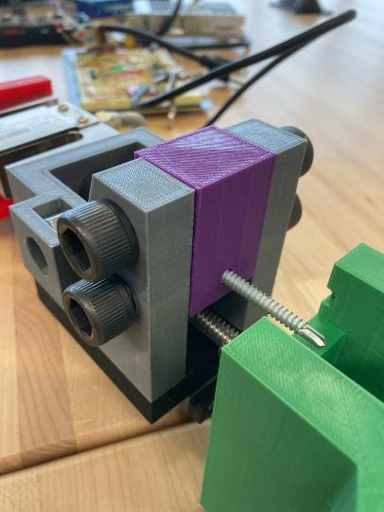

Figure C.2.1: Install the Hammer Block

1. Again, adjust the distance between the grips by manually turning the coupler.
2. Insert the testing specimen into the slot in the Stationary Grip as Figure C.2.2 shown.

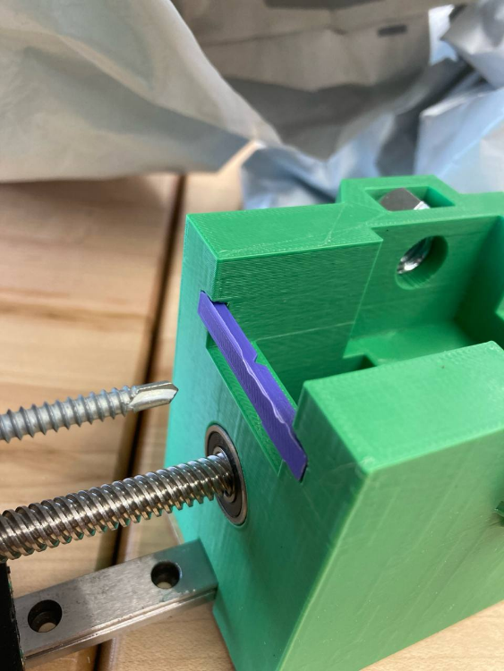

Figure C.2.2. Insert the testing specimen into the slot

1. Now the tester is ready to perform the impact resistance test.

**Part D: Bill of Materials**

|  |  |
| --- | --- |
| **Part** | **Quantity** |
| MGN12H 550mm Mini Linear Rail | 1 |
| MGN12H Carriage Block Black for 12mm MGN12 | 2 |
| 400mm Tr8x8 Lead Screw, Acme Thread, 2mm Pitch, 4 Starts, 8mm Lead | 1 |
| STEPPERONLINE 5:1 Planetary Gearbox Nema 17 Stepper Motor | 1 |
| M3 x 0.5mm, 8mm length socket head screws | 12 |
| M12 x 1.75 mm, 30 mm Long, socket head screws | 6 |
| M12 x 1.5 mm thread, 50 mm Long, socket head screws | 4 |
| Hex Nut   Medium-Strength, Class 8, M12 x 1.5 mm | 4 |
| 60 Grit Sanding Sheet | 1 |
| uxcell 8mm to 10mm Bore Rigid Coupling Set Screw L22XD16 | 1 |
| Uxcell 698-2RS Deep Groove Ball Bearing Double Sealed 1180098 | 3 |
| Alloy Steel Socket Head Screw   Black-Oxide, M3 x 0.5 mm Thread, 20 mm Long | 10 |
| Black-Oxide Steel Hex Nut   Medium-Strength, Class 8, M3 x 0.5 mm Thread | 10 |
| Disposable Needle, Blunt Tip, 16 ga, 1/2 in Length | 2 |
| Dispensing Syringe, 3 mL | 2 |
| MARKAL Machine Oil, 4 OZ | 1 |
| Zinc Plated Steel Drilling Screws, Joins Drywall to Metal Framing, Number 10 Size, 2-1/2" Long | 1 |

**Part E: Arduino Setup and Controls**

1. **Part E: Arduino Setup and Controls**
2. Get the Arduino code file from the Block Breaker GitHub and open it in the IDE. There will be a spot at the top to put your Wi-Fi information, which is required.

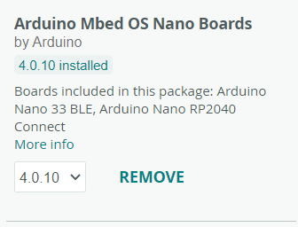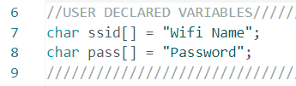

1. Upload the code to the board through a micro-USB connection. Make sure the right board is selected under tools>board>Arduino Mbed OS Nano Boards and be sure the right port is selected in tools>port.
2. The board is now ready to run tests. Opening the serial port in the IDE will allow you to view the board’s outputs and control it remotely. All operations done through the terminal are also bound to the 3 physical buttons, allowing use without a computer connection.

**Part F: Electronics Setup**

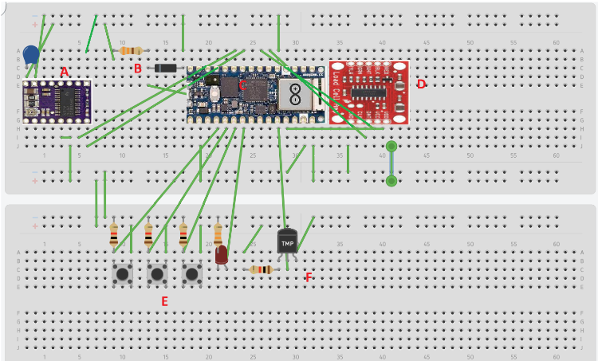

Figure E.1:Full electrical wiring diagram

**Component A: Motor Driver**

Note: If looking for further detail, look at <https://www.pololu.com/product/2133> for specific specs.

1. The purple component marked “A” is the motor driver component. Make sure to put the capacitor in the top left with the positive end (the longer wire) on the left side. Put the positive end of the power supply along the same row of the power supply, with the negative end on the row to its right. The capacitor should now be in series with the power supply.
2. Place a multimeter and measure the voltage on the potentiometer. Measure the voltage between the ground pin and the potentiometer. If using our specific pieces, this voltage should be 0.83V. If unsure, consult with the link in the note. If your stepper motor is working erratically, it is most likely due to wrongly calibrating the current limit.
3. When you’re sure you have calibrated the current limit, put the stepper motor’s wires from left to right in the order blue-red-black –green directly left of the power pins. After this step, the wires should be connected in the orientation positive power source-negative power source-blue motor wire-red motor wire-black motor wire-green motor wire-gap(nothing)-ground. You can also look underneath the motor drive and it should have its pin configuration.

**Component B: Voltage Regulator**

Note: If you plan on using a wire to an Arduino from a laptop, you can disregard this step. This component provides power to the Arduino from the power supply if you would like to use the wireless option.

1. The resistor must be rated for power dissipation, or you will burn it up. Aim for a resistor of around 200 ohms, with 2W dissipation.
2. The Zener diode should be rated for around 7-10V, with around a 1W dissipation to provide adequate voltage and current to the Arduino.

**Component C: Arduino Nano**

If connected correctly, using our code, this component should not need any extra steps. If powered adequately, the LED on the Arduino should be glowing.

**Component D: S sensor amplifier**

1. The S-sensor should have colored wire ends. Connect the colored wires to the corresponding color on the S-sensor.
2. The S-sensor's wire’s may be hard to fit into the breadboard. Try and put some alligator clips with some wires to connect them to the breadboard properly.

**Component E: Buttons**

If set up correctly, these buttons should be able to activate the tensile, impact, and start tests. Be sure to make sure that you’re connecting the resistors and button ends to the ground or positive wires. Otherwise the code will not detect the correct button inputs.

**Component F: Temperature Sensor**

Just like the buttons, make sure you connect the wires to the ground and positive wires properly. Our temperature sensor that the team used. Simply make a voltage ladder with the resistors, with a wire in the same row where the resistors meet to the same input on the Arduino. For example, R2 would be the temperature sensor, and Vout would be a wire toward the same input pin that the diagram’s middle temperature detector is connected to.

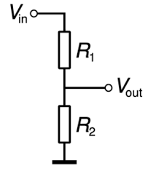

Figure E.2: Voltage ladder

**Part G: Website**

The website is currently running on localhost. It has a home page, register page, login page, user page and register page. I used XAMPP to host the Apache server and MySQL server. I am using OneM2M server to transfer data, but I couldn’t get the code to work to upload data automatically on the server. This is the github page to run the ACME server:-

[ankraft/ACME-oneM2M-CSE: An open source CSE Middleware for Education. (github.com)](https://github.com/ankraft/ACME-oneM2M-CSE)

This github page will help in understanding how the ACME server works:-

[ankraft/onem2m-jupyter-notebooks: A couple of Jupyter notebooks to explain how to create, access and manage oneM2M resources (github.com)](https://github.com/ankraft/onem2m-jupyter-notebooks)

Currently, on my computer I have these configuration setup in acme.ini:-

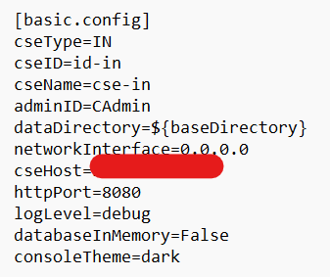

The csehost will be the IP address that the server will work on.